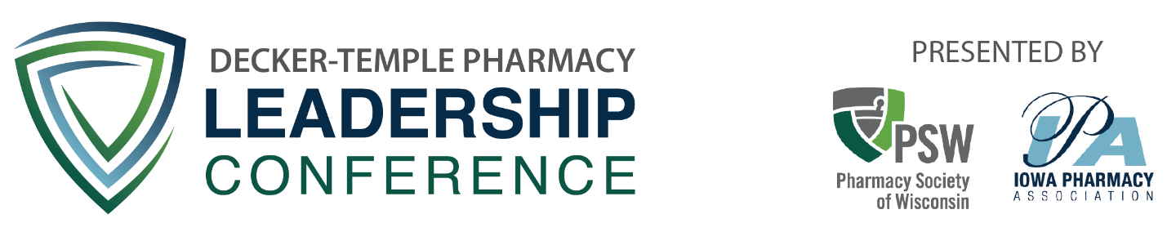

**2023 Decker-Temple Leadership Pharmacy Application**

The Decker-Temple Leadership Pharmacy Conference, a new practitioner leadership conference, takes place at the [Eagle Ridge Inn and Resort](http://www.eagleridge.com/) near Galena, Illinois annually in August. The conference, combining professional and social functions over three days, provides an unequaled opportunity for pharmacists relatively new to their profession to develop skills which enable both personal and professional growth. Participants network with fellow selected pharmacists (10 from Wisconsin and 10 from Iowa) as well as the presidential officers and staff leaders of the Iowa Pharmacy Association and Pharmacy Society of Wisconsin while engaging in programming, recreational activities, and issues discussions. Read more about the conference [here](https://www.pswi.org/Education/Conferences/Leadership-Conference).

The Wisconsin Pharmacy Foundation / Pharmacy Society of Wisconsin and the Iowa Pharmacy Association Foundation / Iowa Pharmacy Association welcome applications from those who represent diversity in race, color, ethnicity, culture, national origin, sexual orientation, age, gender, gender identity, social class, physical ability/attributes, religious or ethical value systems, language, pharmacy practice area, geographic location, and other perspective shaping backgrounds.

**Conference Goals**

1. Provide conference participants with strong leadership training
2. Increase conference participants’ awareness of issues impacting the profession of pharmacy nationally and in their own state
3. Encourage the involvement of all new practitioners in professional and community activities
4. Demonstrate the interest of PSW in developing new practitioners for leadership positions within the profession

#### Sample Conference Agenda

**Thursday**

11:30 am – 12:15 pm    Lunch

12:15 pm – 12:45 pm    Conference Welcome & Group Picture

1:00 pm – 5:00 pm        Meetings to Media: Communicating with Confidence

6:30 pm - 9:00 pm       Dinner and Full Group Networking Activity

9:00 pm - 11:00 pm       Optional: Informal Networking

**Friday**

7:30 am – 8:15 am        Breakfast

8:30 am – 12:00 pm      Diversity, Equity, and Inclusion in Health Care

12:00 pm – 1:15 pm      Lunch

1:30 pm – 5:30 pm        Small Group Team Building Activities

6:30 pm – 9:00 pm        Dinner and Full Group Networking Activity

9:00 pm - 11:00 pm       Optional: Informal Networking

**Saturday**

7:30 am – 8:15 am        Breakfast

8:30 am – 9:30 am        State Breakouts

9:45 am – 11:30 am       Reflection and Goal Setting

11:30 am – 12:30 pm     Lunch

**APPLICATION INSTRUCTIONS**

Pharmacists who are current members of either the Pharmacy Society of Wisconsin or Iowa Pharmacy Association; who reside or practice in Wisconsin or Iowa; and who are within their first 3-15 years of practice (graduated between 2008-2020) are eligible to apply. Pharmacists who are currently a PGY1 or PGY2 resident are not eligible to apply, but are encouraged to apply at a later time.

The Wisconsin Pharmacy Foundation / Pharmacy Society of Wisconsin and the Iowa Pharmacy Association Foundation / Iowa Pharmacy Association welcome applications from those who represent diversity in race, color, ethnicity, culture, national origin, sexual orientation, age, gender, gender identity, social class, physical ability/attributes, religious or ethical value systems, language, pharmacy practice area, geographic location, and other perspective shaping backgrounds.

In **Part 1** of the application, you will be asked for contact information. Please fill out the right column. The applications are de-identified during the review process and therefore, this information will not be provided to the reviewers.

In **Part 2** of the application, you will be asked a series of questions. Type the answer under each question. Each response is limited to a maximum of 300 words. The font must be Times New Roman, 11-point font. The formatting must be single-spaced and have 1/2-inch margins. Part 2 should be on a separate page from Part 1, but each response does not need to be on a separate page. Pictures, graphics, tables, charts, and letters of recommendation are not allowed. Names of individuals and pharmacy organizations in your written responses will be redacted prior to being sent to the reviewers. Therefore, you may choose not to include names of individuals and pharmacy organizations in your written responses to maximize your word count to fully answer the question.

These applications will be scored by 3 reviewers using a rubric (rubric is not published) using a de-identified process. Only completed applications will be relayed to reviewers for scoring. Written feedback on the applications from the reviewers will not be collected by the Wisconsin Pharmacy Foundation / Iowa Pharmacy Foundation, nor provided to the applicants.

Applications are due February 1, 2023. Applications must be sent in a Word document to info@pswi.org.

**PART 1**

**The information in Part 1 will not be provided to the reviewers.**

|  |  |
| --- | --- |
| **Name (First and Last)** |  |
| **Job Title** |  |
| **Organization Employed by** |  |
| **Work Address** |  |
| **Home Address** |  |
| **Cell Phone** |  |
| **Email Address** |  |
| **College of Pharmacy Graduated from** |  |
| **What is your practice setting?** |  |

**PART 2**

**1.What does leadership mean to you? What are examples of how you have been a leader or are working on to be a leader? (300 words maximum)**

Type Answer Here

**2. How have you been involved or desire to be involved in diversity, equity, and inclusion conversations in your career? (300 words maximum)**

Type Answer Here

**3. How would you use your Decker-Temple Leadership Pharmacy conference experience to fulfill your aspirations in the profession of pharmacy and in your community? (300 words maximum)**

Type Answer Here

**4. List the professional, community, business, civic, social, religious, athletic or other activities that you are involved in or wish to be involved in. Why is this involvement important to you? (300 words maximum)**

Type Answer Here

**5. What do you believe are the most important issue(s) facing the profession of pharmacy in your state and nationally? Why do you believe the issue(s) are important? What steps have you taken to learn about or address these issues? (300 words maximum)**

Type Answer Here

**6. What strengths and experiences would you bring to the Decker-Temple Leadership Pharmacy conference? Include a description of your professional and community achievements and goals. (300 words maximum)**

Type Answer Here

**7. What year did you receive your PharmD?**

Type Year Here

**8. The is my (highlight one below) application to Decker-Temple Leadership Pharmacy Conference.**

* First
* Second
* Third
* Fourth
* Fifth